# Durable Furnitures

Alfonso

## Pluto Table Lamp

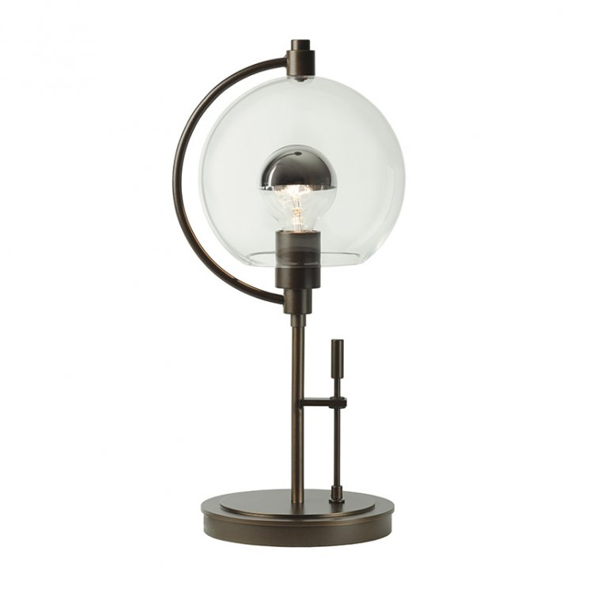

Remember when Pluto was still a planet? We sure do. Hubbardton Forge artisans all agreed and decided to immortalize Pluto in their Pluto Table Lamp. Finely handcrafted in iron and glass, this table lamp exudes an extraterrestrial vibe in its rounded lines and shapes. Take a trip into the far reaches of our solar system from the comfort of your own home with this one-of-a-kind table lamp.